# Conflict Scenario

## **Review**

### Interpersonal Conflict Management Styles

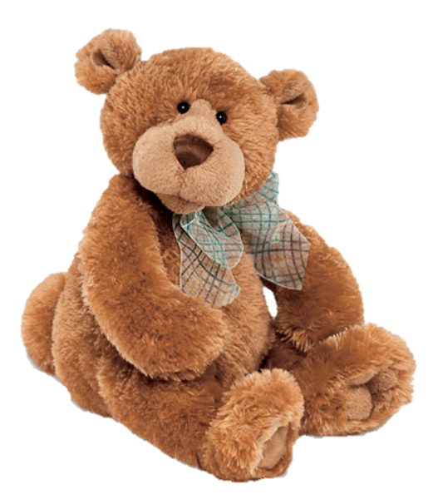

[CC 2.0 BY Matthew](https://www.flickr.com/photos/falcon1961/3304306800/)



[CC SA 3.0 Unported BY Jonathan Zander](https://en.wikipedia.org/wiki/File:Florida_Box_Turtle_Digon3.jpg)



[CC 3.0 BY Superawesomevectors](https://superawesomevectors.deviantart.com/art/Shark-Cartoon-Free-Vector-Illustration-643399222)



[CC0](https://pixabay.com/en/urban-lost-hiding-afraid-1002149/)

Low to High Concern for Other

Concern for Self



CC SA 2.0 Generic BY [Carine06 from UK](https://commons.wikimedia.org/wiki/File:Flickr_-_Carine06_-_%22I_give_up.%22.jpg)



CC 2.0 BY [Zabara Alexander](https://www.flickr.com/photos/zabara_tango/6955720271)

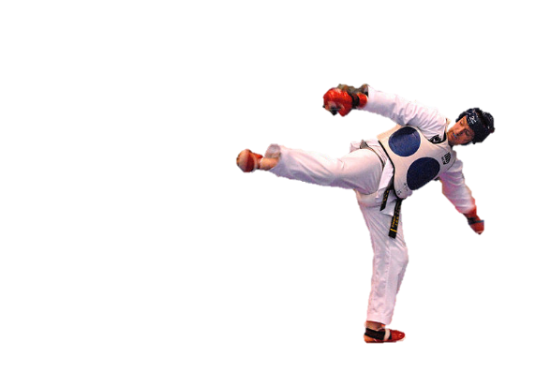

[CC0](https://commons.wikimedia.org/wiki/File:US_Army_53525_Soldiers_compete_in_Tae_Kwon_Do_tournament_for_Warrior_Country_level.jpg)

### **Interpersonal Conflict Resolution**

The following diagram shows a process that can be followed when trying to resolve interpersonal conflict.

### Listening

A considerable proportion of our communication involves listening, yet little attention is devoted to improving listening. HURIER is an acronym for tips that can be used to improve listening.

### “I” Phrases for Conflict Resolution

The “I” phrase is used during conflict resolutions to avoid attacking others. Open the conversation with a statement in first person, passive voice: “I feel … when … because … I would like …”

Adapted from (Dwyer 2012, p. 40)

## **Student Name and ID:** Jake Kenealy 12197775

## **Student Name and ID:** David Schenck 12112782

## **Scenario**

Find a partner. Read the scenario below. Choose one partner to be Joe Bloggs, and the other to be Jane Doe. Together, answer the following to help prepare you for the role play.

## **Scenario: Joe did not complete a task by the deadline**

Joe and Jane are working on a report that is due today. Joe was assigned the task of writing the executive summary. Unfortunately, Joe has not completed the task.

What is the most appropriate conflict management strategy for Jane to use in this situation? (Choose one)

Compete/Force

Compromise

Avoid/Withdraw

Collaborate/Confront

Accommodate/Smooth

Why did you choose the above conflict management strategy?

To address the issue with Joe and see if he needed help completing the task.

### **Listen and Understand**

How could Jane start the conversation?

Hey Joe, I saw that haven’t completed the summary yet, what’s going on?

Describe the purpose of the discussion. Describe the conflict. What questions could Jane ask to determine Joe’s perspective of the situation?

The purpose is to find a solution to completing the task on time and observe to see if action is needed. The conflict is that Joe hasn’t completed his task. Jane could ask Joe why he hasn’t completed the task and if he needs help completing the ask.

Write sentences that features the “I” phrase, such as in the example below:

“I feel *[your feeling]* when *[their behaviour]* because *[effects on you]*. I would like *[alternative behaviour]*”.

Jane: I feel frustrated when you’ve been unproductive because it lowers my chances of passing the assignment. If you think you need help, just come talk to me.

Joe: I feel ashamed when you’re so productive because it makes me feel bad about my own work. I would like to increase my work ethic.

Invent a reason why Joe did not complete the executive summary by the deadline.

Joe thought the report was due next week.

How could Jane paraphrase Joe’s reason for missing the deadline to ensure that she understands Joe’s perspective?

Joe new that he had to do the summary, but he thought he had more time.

### **Empathise**

Now that Jane understands Joe’s perspective, how could Jane empathise with Joe? Write a response that shows that Jane identifies with Joe’s emotions.

Yeah, that’s alright, I’ve been there before. One time I was watching Netflix and I thought it was 2pm but suddenly, it’s dark out. You’ve just got to try to stay on top of things.

### **Apologise**

Include an apology if it is appropriate.

I’m really sorry, Jane. I genuinely did plan on doing the summary, but time just slipped away from me

### **Offer Solution**

What question could Jane ask to help build Joe’s involvement with potential solutions?

Do you want any help writing the summary?

Come up with a way for Jane and Joe to settle on a solution.

Jane and Joe work together to write the summary so that it can be submitted on time.

### **Resolution**

How could Jane resolve the conflict? Jane needs to ensure that Joe agrees. Write a response that outlines appreciation for the solution.

Jane could ask Joe if he wants to work together to write the summary. Perhaps he could tell her his ideas and she structure it to fit the requirements.

### **Reconciliation**

How could Joe reconcile the relationship and let Jane know that she is important to him?

Joe could ask if Jane if he could shout her a trip to the movies.

How can Jane let Joe know she is listening while Joe is talking?

Maintain eye contact, don’t interrupt, don’t multitask, focus on him and not internal monologue, paraphrase his points and ask if she has them correct, and ask clarifying questions.

What could Jane do if Joe started to withdraw from the conflict at any stage?

Reassure Joe that she isn’t upset, she just wants to know how she can help him get it done.